Ref: PS/O/Hitachi/587/ 25-26 Date: 30/05/2025
TO,
Hitachi Energy India Ltd
16TH KM Raman Board
Mysore-Ooty Road Thandavapura -571302
Title of Job: Supply of Inspection Table
SL NO | DESCRIPTION | SAC Code | QTY | UOM | Unit Rate | Total  Amount
1 | Supply of Inspection Table For BPD2  Material To be Used  *SS304 1.6mm thk Plate 1000X2000=1nos  *SS304 Square Tube = 9mtr  *Bottom 2”Nylon Bush = 4nos  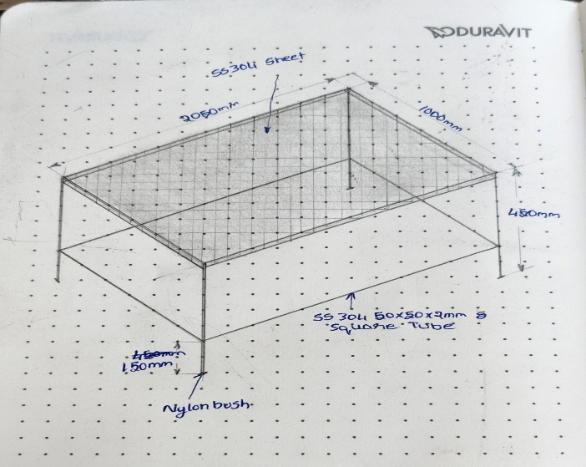 | 732393 | 1 | Nos | 52000 | 52000
 |  |  |  |  |  | 52000
2. COMMERCIAL TERMS & CONDITIONS:
Payment | : | 100% Against invoice.
TAXES | : | GST 18% Extra applicable.
Excluded | : | Required construction power.
Validity | : | 7 days from date of offer.
Payment Terms | : | 1. Payment by RTGS/NEFT OR cross and order cheques only.  2. All dispute subject to Mangalore jurisdiction.  3.This Quotation rate is for only 7daysPayment should be done after Submission of bill.  4. If Payment is not done with in 10day after submitting Bill. 10% Will be charged Monthly.
Ordering Information | : | Please raise your Purchase Order in the name of “P.S.Engineering Services”, No.5-141/11 Thimmpa Poojary Sankirana, SajipaMuda Bollai Bantwal Taluk. Dakshina Kannada-574231 ” GSTIN: 29IYRPK6367K1Z8
We trust the above offer is in line with your requirement. Please do feel free to revert incase you need further clarification.
Thanking You,
With regards
For P.S.Engineering Services
PRADEEP KULAL

